# Proposal Project 2

## Technical

**Python Flask powered API which includes creation of API endpoints:**

Use Python Flask to get API for weather articles and put into PostgreSQL database.

**HTML/ CSS, Javascript website:**

Option B:

* Home page - UV
* Temperature
* About page

**Use at least one new JS library:**

* Top map: D3 contour (<https://github.com/d3/d3-contour>)



* ?Middle: Bar or line graph showing average of last 5 years for one year?
* History visual: Nivo calendar (<https://nivo.rocks/calendar>) – last year

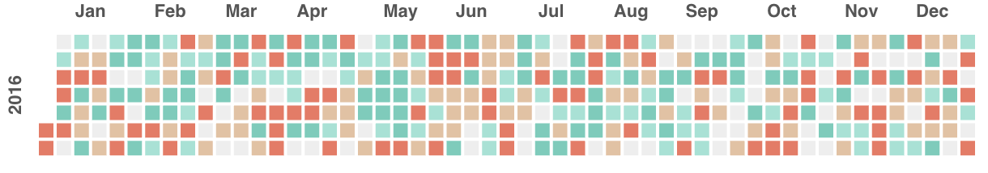

**Dataset with at least 100 records:**

Weather data for WA will contain more than 100 records. We have different locations and DateTime.

**Use user-driven interaction:**

Search box & menu with home and about pages

**Include at least 3 views:**

1. Index page - UV
2. 2nd page - Temperature
3. 3rd page - About page

## Work flow chart

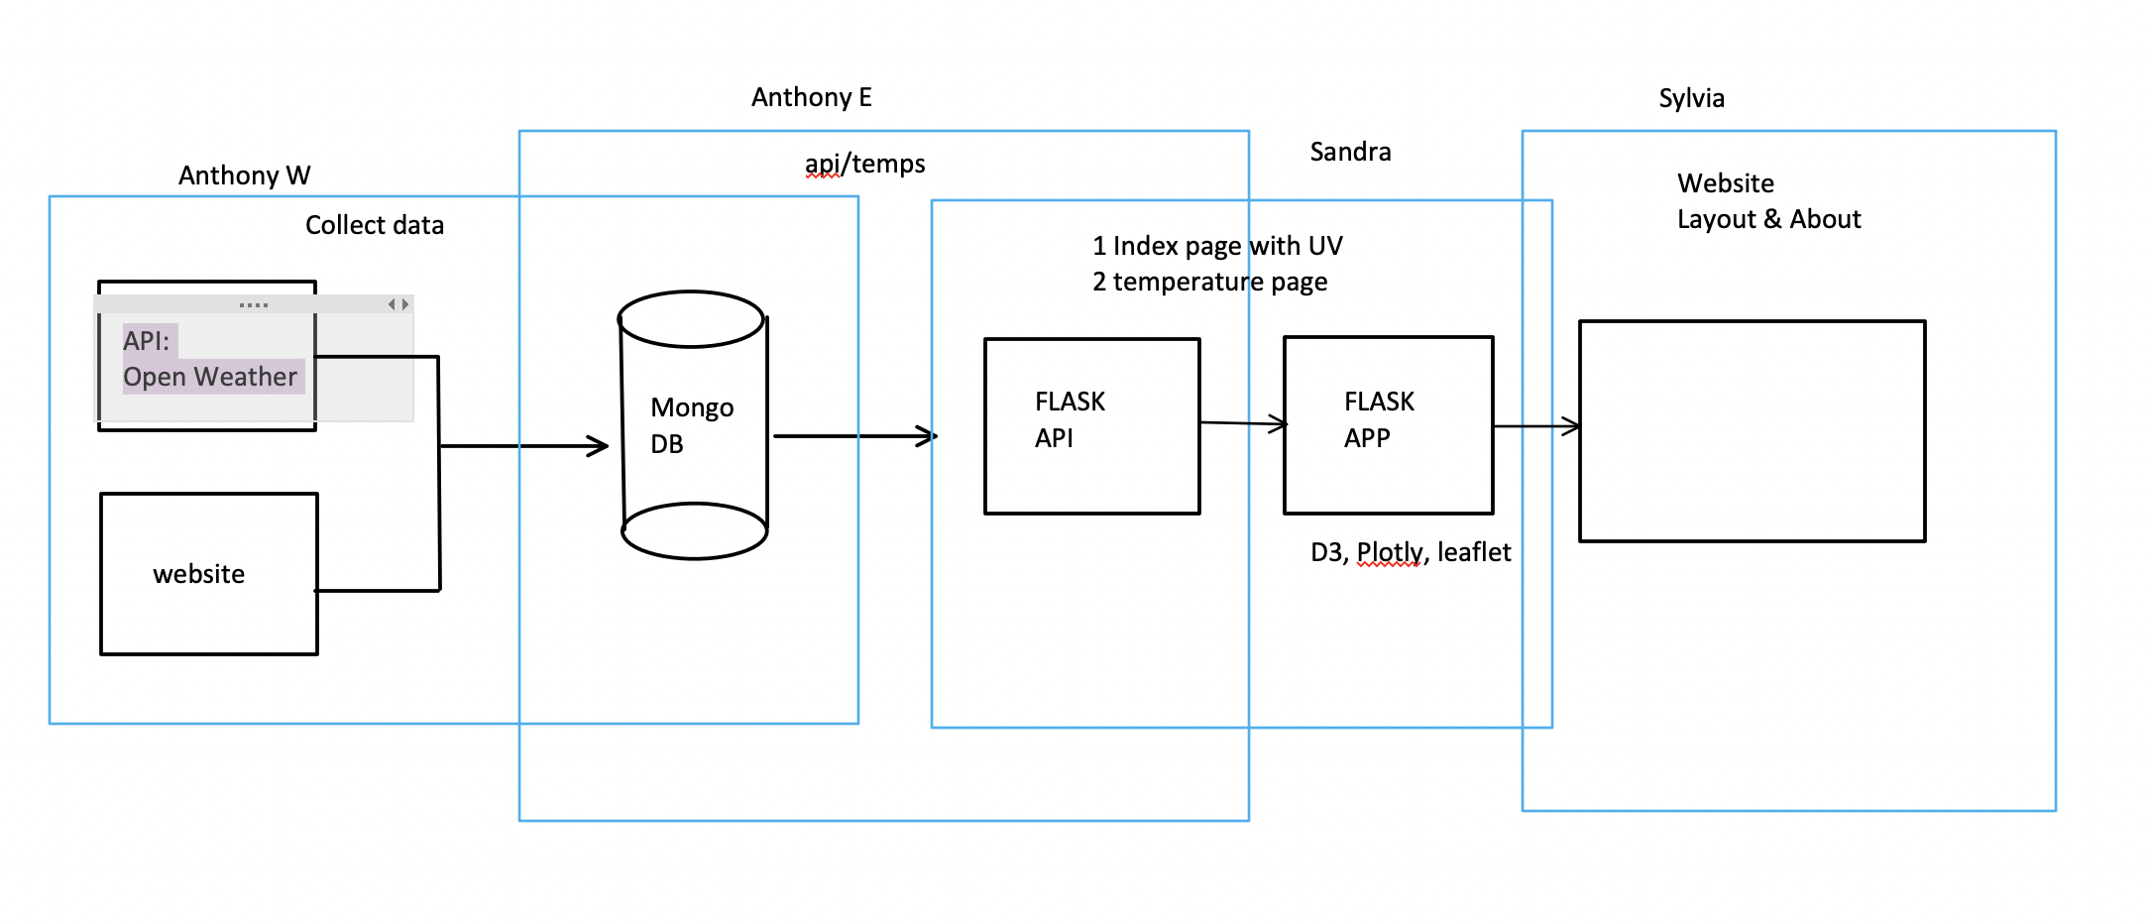

## Sketch page layout

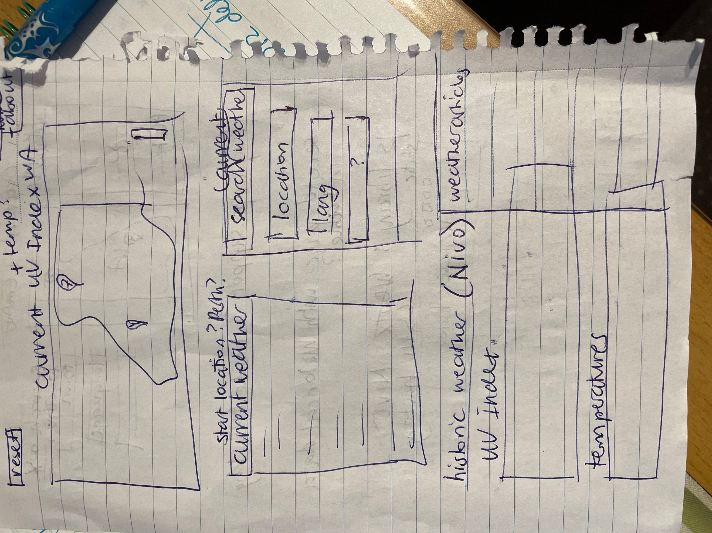

## Presentation

**Subject**: Provide UV index and temperature information for WA

**Questions**:

1. Has the UV index increased over time?
2. Does the temperature affect the UV rating?

**Data**:

Searched for Weather API’s. There are a few options but they are mostly paid or free for only a month. We chose OpenWeathermap as it is free and has the UV rating and temperatures available.

**Conclusions**:

**Implications**:

**Tell a good Story**:

Tourism WA has engaged our small firm to present the UV index and the temperature weather data for residents and tourists to increase the use of sunscreen and to prevent skin cancer. Awareness